ProLignin - High-value products from lignin side-streams of modern biorefineries

Project coordinator:
Dr Tiina Liitiä
VTT Technical Research Centre of Finland
Tietotie 2, FI- 02044 Espoo, Finland.
Telephone: +358-40-7552387, E-mail: tiina.liitia@vtt.fi

Project partners:
University of Helsinki/ Department of Chemistry (FI), North Carolina State University (US), AkzoNobel/ Packaging Coatings (US), University of Hamburg (DE), Latvian State Institute of Wood Chemistry (LV), Instituto de Recursos Naturales y Agrobiología de Sevilla (ES), Fraunhofer-ICT (DE), RAMPF Ecosystems GmbH & Co.KG (DE), RAMPF Giessharze GmbH & Co KG (DE), University of Milan-Bicocca (IT), Biochemtex Italia Srl (IT), Momentive Specialty Chemicals Oy (FI), Valmet (FI), Stora Enso Oyj (FI), Suzano Pulp and Paper (BR)

The aim of ProLignin project was to improve the profitability of present and future biorefineries, i.e. lignocellulosic bioethanol production plants and traditional pulp mills, by up-grading of the side-stream lignins to novel high-value products. Another aim was to create more sustainable biobased products by substitution of the oil based raw materials with the industrially available lignin residues. The target products were lignin based thermoset resins for adhesives, foams and coatings, dispersants for fluid control, and thermoplastics for composites.

During the project, lignin by-products from present and future biomass fractionation processes with distinct structural features were produced . All the available lignins were thoroughly characterized, further modified and their suitability for the target applications was evaluated in order to reveal the structure-property correlations.

For thermoset resins (PF, PU, epoxy) and self-binding particle boards lignins were tested as such, and also various activating modifications and degradative means were developed. For PF resins, lignins with low degree of methoxylation (softwood, wheat straw, bagasse) provided best performance. By phenolation, the reactivity of lignin could be further improved. Steam explosion was shown to be a potential pretreatment method for self-binding particle boards, and the performance could be further improved by addition of isolated lignins. High purity lignins provided industrially processable PU resin products, and the possibilities to use lignin varied greatly from product and formulation to another. By base catalysed lignin degradation, the viscosity control for PU resins was significantly improved, although additional chemical modification was required for introduction of reactive aliphatic hydroxyl groups. Lignin based coatings were prepared for metal cans with good cure and mechanical properties by using 70-80% lignin in phenolic resin formulations with various crosslinkers. For composites, thermoplastic lignin was produced by esterification, providing improved miscibility of lignin and PE. However, the use of lignin increased the stiffness and reduced the tensile strength of blends, which was observed also for fiber-reinforced blends. For concrete plastization, a cost-competitive lignin modification method was developed, providing better performance than presently used lignosulphonates.

Based on LCA, most sustainable lignin based products can be produced when using unmodified lignin as such.

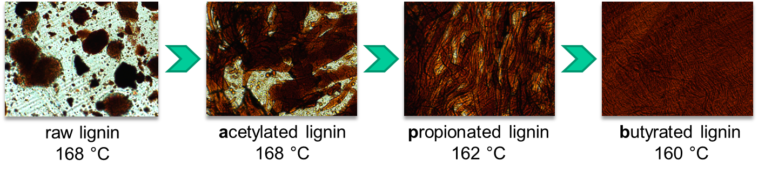
Figure 1. Effect of lignin esterification on compatibility with PE (Dehne et al. UniHH).

