PowerBonds - Enhancement of fibre and bond strength properties for creating added value in paper products

Project coordinator:
Professor Pasi Kallio
Tampere University of Technology
Korkeakoulunkatu 10, FI-33720 Tampere, Finland.
Telephone: +358-500-525546, E-mail: pasi.kallio@tut.fi

Project partners:
Papiertechnische Stiftung (DE), OFFIS Institute for Information Technology (DE), Stora Enso Deutschland GmbH (DE), INNOWEP GmbH (DE), Grenoble INP-LGP2 (FR), Papeteries Emin Leydier (FR), Munksjö Arches SAS (FR), UPM-Kymmene (FI), VTT Technical Research Centre of Finland (FI), Åbo Akademi University (FI), Sappi Finland Oy (FI), KTH Royal Institute of Technology (SE), Stora Enso AB (SE), Graz University of Technology/ CD-Laboratory for Surface Chemical and Physical Fundamentals of Paper Strength (AT), Central Bank of the Netherlands (NL)

Modern paper products need to be produced in a lean, sustainable and efficient way. The energy and material consumption can be decreased by lowering the grammage of the structure. However, lowering the grammage means that strength and runnability properties of the paper structure are reduced.

The challenge that the PowerBonds project tackled is the lack of understanding on the strength mechanisms in fibre network based products. For example, with traditional methods it is not possible to separate the mechanisms behind the strength: the influences of i) strength additives or refining, ii) fibres and their property distributions, iii) the structure of the network, etc. Thus, it is extremely challenging to predict these influences for instance on the grammage and runnability.

The main achievement of PowerBonds is the implementation of a new holistic infrastructure to study strength related problems of fibre products. The infrastructure combines knowhow, methods and tools in fibre modification, characterization and imaging of individual fibres, bonds and fibre networks, and numerical modelling at various length scales.

For example, several novel micro- and nanorobotic instruments and micro- and nanotomography methods were developed and applied for the first time in the measurement of strength related properties of fibres, bonds and fibre networks. Furthermore, the project developed numerical models covering the deformation mechanisms from the micro level (fibre bond) to fibre network and to the continuum scale (large webs).

During the project, the use of the new tools and methods were demonstrated in seven specific use cases identified together with the European industrial partners: effects of strength additives (using four different chemicals), effects of refining, effects of furnish variation, fibre-to-fibre interaction in a wet state, unknown breaks in a paper machine, initial wet strength in a paper machine, and degradation of bending stiffness in banknotes.

As a result of the PowerBonds project, understanding the strength of products based on fibre networks does no longer require a black-box approach. With the infrastructure developed in the project, it is now possible to combine experimental data and numerical simulation from micro to macro level in order to understand the strength mechanisms and thus, to improve fibre products.

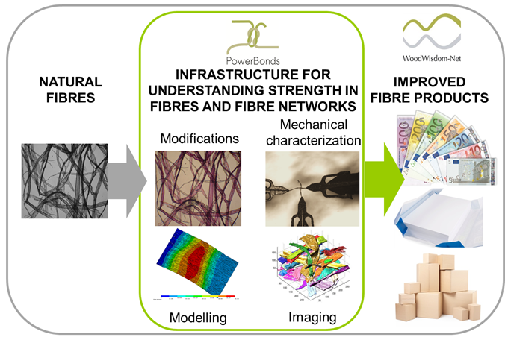
Figure 1. PowerBonds: from unpredictable product properties to understanding of underlying strength mechanisms and to improved fibre products.

