PINOBIO - Pinosylvins as novel bioactive agents for food applications

Project coordinator:
Professor Atte von Wright
University of Eastern Finland, Institute of Public Health and Clinical Nutrition, Department of Clinical Nutrition
Yliopistonranta 1, FI-70211 Kuopio, Finland.
Telephone: +358-50-5376030, E-mail: atte.vonwright@uef.fi

Project partners:
University of Vigo/ Chemical Engineering (ES)
Latvian State Institute of Wood Chemistry (LV)
University of Lubljana/ Biotechnical faculty (SI)
Åbo Akademi University/ Process Chemistry Centre (FI)

Wood, especially knotwood of Pinus species (at present a side stream of wood industry) is an abundant source of stilbenes, such as pinosylvin and its derivatives. These compounds have demonstrated considerable antimicrobial activities and cytotoxicity against a murine hepatic carcinoma cell line.

The aim of the PINOBIO project was upscale the extraction of pinosylvin and its derivatives from wood and further characterize their biological activities with a clear focus on potential applications (antimicrobials in foods and industrial processes, functional ingredients). The project addressed the following key tasks:

• Optimization of the production of pinosylvins from pine (including the best available sources of pinosylvin-rich trees) and synthesis of selec ted derivatives;
• Elucidation of bioactivities (antimicrobial properties, particularly against Listeria) of wood-derived pinosylvins and their derivatives;
• In particular, verification pf the antidiabetic potential of these compounds by in vitro relevant to in vivo conditions;
• Creation of a basis for the evaluation of the industrial potential of pinosylvins from pine or derivatives of the same for an eventual commercial product development.

Pinosylvin and its derivatives (Figure 1) are chemically very similar to resveratrol, a stilbene found in grapes and berries. Resveratrol has been associated with many beneficial human health effects. In this study the extraction of pinosylvin and pinosylvin monomethylether from Pinus trees was optimized and their biological activities were screened using different in vitro techniques.

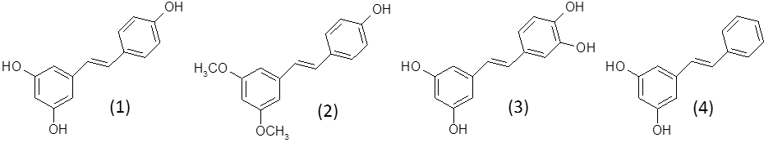

Figure 1. Structures of the stilbenes resveratrol (1), pterostilbene (2), piceatannol (3), and pinosylvin (4).

While the age and growth conditions of the trees affected the pinosylvin contents, the recovery was generally high after relatively straightforward organic extractions. Both pinosylvin and pinosylvin monomethylether proved to be efficient antibacterial and antifungal compounds, and the effects of pinosylvin on the energy metabolism of cultured human cells closely resembled that of resveratrol. Provided that the safety aspects of pinosylvin and pinosylvin monomethylether can be satisfactorily addressed, these compounds could be used as novel antimicrobials and biocides, and even as functional food supplements and pharmaceutical products.

