LBTGC - Load bearing timber-glass composites

Project coordinator:
Professor Wolfgang Winter
Vienna University of Technology, Department of Structural Design and Timber Engineering,
Karlsplatz 13 / 259-2, A-1040 Vienna, Austria
Telephone: +43-1-58801-25410, E-mail: winter@iti.tuwien.ac.at

Project partners:
Knapp Ltd. (AT), Haas Fertigbau Holzbauwerk GmbH & CO. KG (AT), Ziviltechniker Architekt Werner Hackermüller (AT), Petschenig glastec GmbH (AT), HERMANN OTTO GmbH (AT), Glafo AB (SE), Linnaeus University/ Department of Civil Engineering (SE), Södra Timber AB (SE), Pilkington Floatglas AB (SE), Sika Sverige AB (SE), Glasbranschföreningen (SE), NCC Construction Sverige AB (SE), Stora Enso Timber AB (SE), Technische Universität Dresden/ Institute of Building Construction (DE), GUMPP & MAIER GmbH (DE), Istanbul Technical University/ Faculty of Architecture (TR), Turkish Timber Association (TR), Trakya Cam Sanayii A.S. (TR), University of Maribor/ Faculty of Civil Engineering (SI), Contemporary Building Design, d. o. o. (SI), University of Ljubljana/ Faculty for civil and geodetic engineering (SI), Universidad Catolica; Escuela Arquitectura (CL), WOODMetal (BR), AEC –SP: Associação Escola da Cidade – Faculdade de Arquitetura e Urbanismo – São Paulo (BR), IPT – Instituto de pesquisas tecnologicas (BR), Penha Vidros (BR)
The project LBTGC aimed to develop a building system composed of timber and glass sections.

The project included an evaluation of current experience with timber-glass composite (TGC) elements in respect to an optimization as load-bearing structures, a study on adhesives, timber and glass as composite components including an identification of relevant material properties events and a study of a variety of commercially available adhesives with inclusion of results of previous research on TGC-elements with reference to their response to long-term and seismic loads.

The experimental studies on adhesives aimed to take into account all steps in the process of bonding and included a chemical and physical classification as well as the identification of crucial parameters such as adhesion to timber and glass surfaces, resistance to environmental influences, long-term performance, homogeneity of materials and application processes.

Currently used TGC systems for walls, beams and floors were critically assessed with regard to structural performance (including manufacturing, workability, erection etc.). The most important characteristics of the different components were identified and optimization potentials were pointed out. Concepts for coactive LBTGC-elements were developed and tested. Ideas for applications were developed and the possible use of LBTGC shear wall elements in a façades or glazed roofs was evaluated. The connection details of LBTGC-elements (beams and walls) and their connection details for a row of different construction typologies were designed and assessed. In addition, the problem of seismic loads and other horizontal and dynamic forces was a point of interest and investigations.

Various types of components have been studied so far: 1) Shear walls with soft, medium and stiff adhesives and 2) Beams with soft, medium and stiff adhesives. The project results indicate that LBTGC-elements can be a) adequately designed using a traditional strength approach, b) described using a combination of strength and buckling analysis and c) described by beam theory using the γ-method according to Eurocode 5. The results can provide a basis for material models used for numerical analysis and engineered design solutions. Conceivable applications are numerous ranging from entire façade elements to interior wall partition systems etc.

The developed TGC multi-story façades were implemented within the framework of various pilot projects with the aim of a long-term monitoring under different climatic conditions.

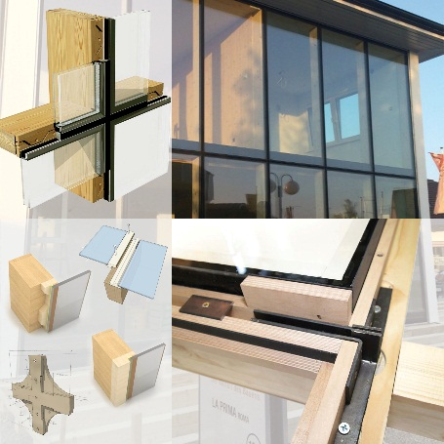
Figure 1. Applications of multi-story timber-glass facades, Blaue Lagune HAAS Haus, Austria (top right) and various developed connection
Picture Credit: HAAS Fertigbau Holzbauwerk GmbH & Co. KG (top right) & Department of Structural Design and Timber Engineering (IT), Vienna University of Technology (VUT)
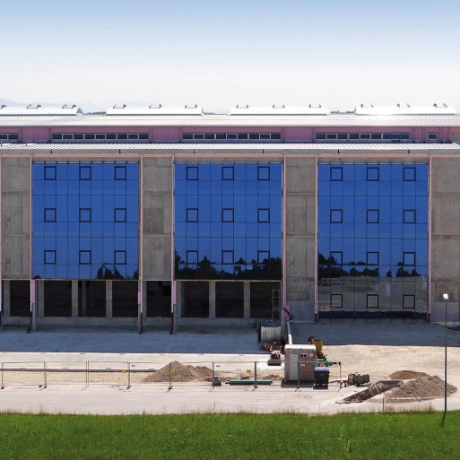
Figure 2. Application of multi-story timber-glass facades and long-
term monitoring, Otto Chemie Building, Fridolfing, Germany
Picture Credit: Hanspeter Petschenig, Petschenig glastec GmbH

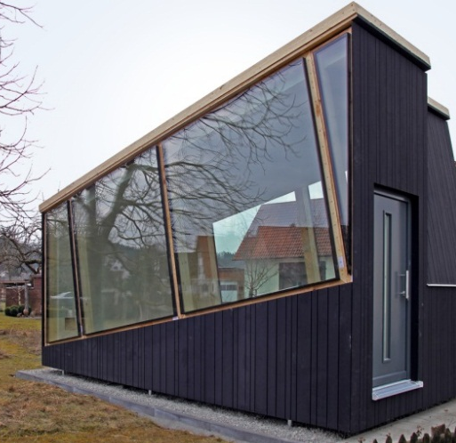
Figure 3. Development and design of a pilot project comprising a load-bearing timber-glass façade. Load-bearing timber glass pavilion in Binswangen, Germany. Design: Gumpp & Maier GmbH
Picture Credit: Technische Universität Dresden/ Institute of Building Construction, Felix Nicklisch

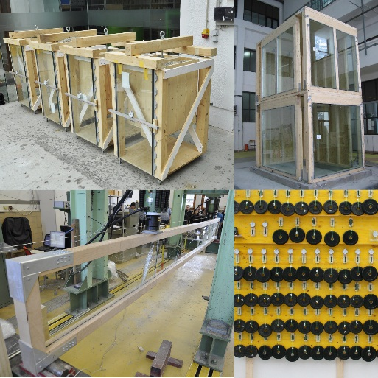
Figure 4. Long-term tests (top left and bottom right), test on TGC-beam (bottom left) and seismic test on the shaking table (top right)
Picture Credit: University of Maribor/ Faculty of Civil Engineering (top right) & Department of Structural Design and Timber Engineering (IT), Vienna University of Technology (VUT)

