GREASE - A novel lipid platform to sustainable bio-based products from low-value forestry streams through multi-functional fatty acids

Project coordinator:
Dr Tiina Nakari-Setälä
VTT Technical Research Centre of Finland,
Tietotie 2, FI-02044 VTT (Espoo), Finland.
Telephone: +358-40-8215794, E-mail: tiina.nakari-setala@vtt.fi

Project partners:
Fraunhofer ICT (DE)
University of Helsinki (FI)
Anadolu University (TR)
Technical Research Institute of Sweden (SE)
Novamont S.p.A. (IT)
Rampf Ecosystems GmbH & Co. KG (DE)
Stora Enso Oyj (FI)
Arizona Chemical Oy (FI)

Bulk chemical products are today made mainly from fossil resources. However, industry is actively developing alternative biomass-based green products. The aim of the GREASE project was to develop novel chemical and biotechnological processes for upgrading of low cost wood-based fatty acids obtained from available industrial streams such as tall oil and birch bark to value-added oleochemicals to be used as bio-based coatings, adhesives, resins, elastomers and bioactive fine chemicals.

GREASE project addressed many core questions of lipid platform: how to exploit wood fatty acids in sustainable products that are able to replace current end-products manufactured from fossil resources and to achieve novel business potential for the forest and chemical industries. In particular, the project dealt with high volume bulk products with considerable impact on sustainability:

- Cost-competitive, partly novel, non-food biomass oils were used as raw material for oleo chemicals instead of vegetable food-grade oils;
- Optimized selective oxidation methods of fatty acid mixtures allow selective production of diacids, diols and aldehydes with tailored chain lengths compared to rather unspecific metathesis process resulting in numerous by-products;
- Proof-of-concept completed for selective and environmentally friendly bioconversion route for production of diacids exploiting robust, industrial production hosts instead of pathogenic, industrially non-relevant microbes known to produce diacids from fatty acids;
- Sustainable isolation method with minimized solvent usage developed for purification of high volume and quality suberin fatty acids and botulin;
- Partly bio-based (up to 70%) polyurethane products (rigid foams and elastomers) developed and demonstrated with really promising properties like high hydrolysis resistance, bending strength etc. instead of using fossil based resources for manufacturing of polyols nowadays used in polyurethanes;
- New value-added product possibilities for both TOFA and suberin fatty acids were established.

The industrial relevance of the GREASE project lies in the fact that the participating industrial partners recognized the importance of broadening raw material sources and in particular finding alternatives that do not compete with food production. Forest-based fatty acids are expected to be cost-competitive with current food-grade fatty acids and to improve the competitiveness in the long run. Finally, all this can lead to new business opportunities related to products used e.g. in cosmetics and pharmaceutical industries.

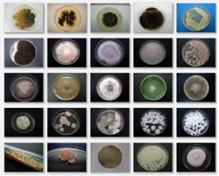
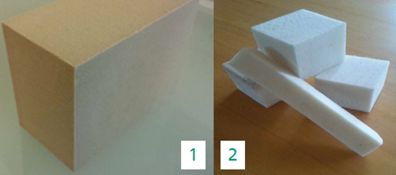
Figure 1. Rigid PU foams from bio-polyols Figure 2. Bioactivity testing of fatty acid derivatives

