COOL - Competing uses of forest land

Project coordinator:
Dr Regina Rhodius
University of Freiburg/ Chair of Forest and Environmental Policy,
Tennenbacherstr. 4, DE-79106 Freiburg, Germany.
Telephone: +49-761-2033713, E-mail: sabine.dehn@ifp.uni-freiburg.de

Project partners:
Forest Research Institute of Baden-Wuerttemberg (DE)
European Forest Institute/ Central European Regional Office and the Observatory for European Forests (DE)
University of Freiburg/ Chair of Forest and Environmental Policy (DE)
The Natural Resources Institute Finland/ Finnish Forest Research Institute (FI)
Forest Sciences Center of Catalonia (ES)
Norwegian University of Life Sciences/ Department of Ecology and Natural Resource Management (NO)
University of Ljubljana/ Biotechnical Faculty (SI)

Wood as a renewable source of energy has received increasing attention in the European context during the last two decades. The EU targets on climate and energy are based on the precondition of a further increase in energy wood production and use. Nevertheless, such an increase is expected to intensify the competition 1) for wood among different wood-based industries, and 2) between wood production and other forest ecosystem services such as carbon sequestration and biodiversity.

In light of this, the European research project “COmpeting uses of fOrest Land” (COOL, www.cool-project.uni-freiburg.de) investigated in how far the demand for energy wood can be met without compromising other policy objectives and fuelling existing stakeholder conflicts. Hereby the researchers placed emphasis on the participation of stakeholders by conducting more than 100 interviews, three stakeholder workshops and by investigating stakeholder opinions about the importance of national strengths, weaknesses, opportunities and threats (SWOT) regarding three scenarios for energy wood utilization in 2030.

The analysis of energy wood related management approaches in the five participating countries has shown that the contribution of wood resources to energy supply and the types of energy wood vary across the studied countries. However, energy wood has mainly been a by-product of round wood production in all countries except Spain. From the perspective of the interviewed stakeholders in all five countries, the large wood reserves and the existing technical expertise are the main strengths of, and opportunities for, domestic energy wood production and use. Across all countries, stakeholders emphasized the importance of an improved political framework for energy wood production and utilization as well as improvements in forest management as the most important aspects influencing current and future energy wood utilization. For future energy wood production and utilisation within the studied countries, six main challenges were identified through the COOL analyses: 1) to strengthen the political framework, 2) to mobilise wood resources, 3) to manage competition for wood, 4) to preserve ecosystem services, 5) to address uncertainties regarding climate change, and 6) to raise public awareness.

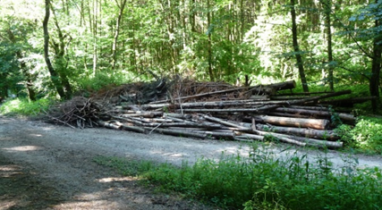
Picture 1 (by K.Wirth): Will there be enough nutrients left in the forest if harvest residues are used for energetic purposes? – One of the questions COOL posed to stakeholders to canvas their opinion.

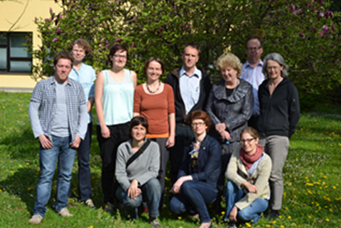
Picture 2: The COOL team during an internal meeting in Ljubljana, 2014. Upper row, from left to right: Vasja Leban (ULJ), Leena Kärkkäinen (LUKE), Kristina Wirth (FVA), Regina Rhodius (IFP), Janez Krč (ULJ), Lidija Zadnik Stirn (ULJ), Mikko Kurttila (Luke), Berit H. Lindstad (NMBU); bottom row, from left to right: Elena Gòrriz (CTFC), Špela Pezdevšek Malovrh (ULJ), Dörte Marie Peters (IFP).

