CellAssembly - Self-assembled biomimetic wood-based nanocomposites

Project coordinator:
Professor Olli Ikkala
Aalto University, Department of Applied Physics, Molecular Materials
Puumiehenkuja 2, FI-02150 Espoo, Finland.
Telephone: +358-9-47023153, E-mail: olli.ikkala@aalto.fi

Project partners:
Aalto University, Department of Applied Physics (FI)
DWI at RWTH Aachen University (DE)
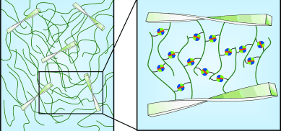
Aalto University/ Department of Forest Products Technology, Forest Products Surface Chemistry (FI)
KTH - Royal Institute of Technology/ Department of Fibre and Polymer Technology (SE)

There are strong societal needs towards sustainable materials, sustainable and energy efficient processes, as well as materials that allow saving of energy, still combining advanced mechanical and other functional properties. An example would be offered by low density, mechanically excellent renewable materials which save fuel energy in mobile technologies and transportation, e.g. in mobile telecommunication, mobile computers, automobiles, and aerospace as they allow lightweight construction.

The overall aim in CellAssembly was to develop concepts, scientific understanding of toughening mechanisms, and realizations towards lightweight sustainable biomimetic nanocomposites with extraordinary combination of stiffness, strength, and toughness, as relevant for applications, as well as selected new functions. The challenge was to maintain the stiffness and strength, while increasing the strain-to-failure. This clearly requires synergic mechanical properties and calls for new concepts towards biomimetic materials principles. The idea was to design and form core-shell nanofibrils/nanowhiskers/nanoclays, and subsequently process them into bulk composites via self-assemblies, spun into self-assembled fibers or expanded into robust composite foams.

CellAssembly project developed next generation self-assembled biomimetic composites with first evidence of synergistic improvement of both strength and strain, and achieved fundamentally new understanding on two mechanisms in biomimetic composites:

- The effect hydration of the self-assemble nanolayers causes a ductile-brittle transition
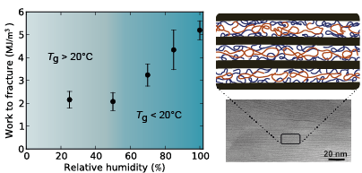

Brittle-to-ductile transition in a self-assembled nacre-inspired poly(vinyl alcohol)/nanoclay composite based on a hydration-induced glass-to-rubber transition in the 2D-nanoconfined poly(vinyl alcohol) layers.

- Supramolecular binding of the nanosheets in nacre-mimetic composites allows sacrificial bonds

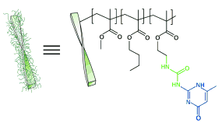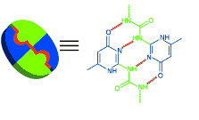

CellAssembly project produced also methods for formation of core-shell nanofibrils through pH modulated adsorption and their subsequent packing, as well as methods for alignment of nanocellulose nanocomposites and fibers inside solvent baths. During the project there was collaboration with companies such as UPM and Tetra Pak but also with some new start-up companies (Betulium and Xylocel).

