The BREDNET-SRC consortium: association mapping in short rotation coppice willow (*Salix viminalis*)

Short Rotation Coppice (SRC) willow (genus *Salix*) is amongst the most advanced second generation energy crops in temperate regions due to its potential for high biomass yields in short timeframes, an ability to re-sprout after multiple harvests, simple and low cost propagation and a broad genetic base.

The over-arching aim of this project is to raise the efficiency and improve the delivery of public research supporting the genetic improvement of Short Rotation Coppice willow for wider environments and future climates. The research is designed to deliver maximum additive output within the context of the resources available and will build upon long-standing national research programmes that underpin the genetic improvement of willow as a bioenergy crop.

A key factor for success in crop improvement is a fundamental understanding of the different elements and interactions contributing to a complex target trait such as biomass yield. Molecular-genetic and genomic approaches can be implemented to dissect the basis of complex traits at the genetic and molecular level. Furthermore, these approaches can provide understanding of the key interactions between genotype and environment.

In this project we have applied association mapping techniques to a population of >360 unique *Salix* *viminalis* genotypes collated from several collections and natural stands across central Europe. We have established four fully replicated experimental plantations, two in England and two in Sweden which encompass differing climate and soil types. Assessments of yield indicators such as bud-burst, stem number, height and diameter and onset of senescence, have now been made over a number of seasons. Additionally a greenhouse drought experiment showed a genotype dependant response that suggests the potential to breed more drought tolerant *S. viminalis* cultivars.

The collection was screened with 38 heterogeneous microsatellite markers spanning the willow genome. Analysis of the resulting data indicates a significant population structure (N=4). A subset of genotypes were selected for a secondary experiment in which they were planted both on poor arid soil and a highly productive soil on the same farm. A transcriptomic analysis was then performed to identify genes that were differentially expressed in the two environments. Differentially expressed genes identified in this experiment, as well as ~150 other candidate genes from literature and QTL experiments were then re-sequenced in 24 diverse genotypes to identify natural gene variants. Of these, 1586 SNPs were selected for genotyping in the entire population using Golden-gate SNP genotyping assays. Preliminary analysis of results from the first assay comprising 135 genes has identified a number of SNPs that are linked to bud burst, shoot number and rust resistance traits. Further results are currently in the analysis pipeline.

This project has established four *Salix viminalis* field trials in diverse geographic locations. These have been genotyped to assess their molecular diversity and a broad range of yield related phenotype measurements taken over the course of a full growth – harvest cycle. The phenotypic data accumulated as well as the sample material itself are important resources both for continuing analysis at the molecular and field level as well as for plant breeding. Similarly, the sequence and genotype data contribute to a database of several thousand genetic markers, a number of which have now been linked to yield related traits. This will improve our understanding of key complex traits and direct our plant breeding efforts towards the attainment of high biomass yield in this environmentally adaptable and economically viable bioenergy crop.

[Lantmännen - logotypeLantmännen - logotype](http://www.lantmannen.se/sv/Lantmannen-CO)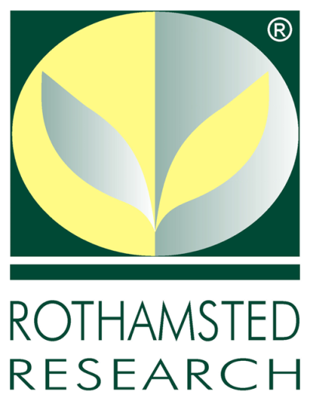

[](http://www.uu.se/)