WOP - WoodSupply

Project coordinator:
Professor Jaakko Kangasjärvi
University of Helsinki
Viikinkaari 1, FI- 00014 Helsinki, Finland.
Telephone: + 358-294-159444, E-mail: jaakko.kangasjarvi@helsinki.fi

Project partners:
University of Helsinki (FI), SLU - Swedish University of Agricultural Sciences (SE), Max Planck Institute of Colloids and Interfaces (DE)

WOP aimed to work on fundamental aspects of wood supply since woody raw material for industrial use will rely increasingly on high-efficiency forest production systems using superior trees, hybrid aspen (Populus tremula × tremuloides) as a model tree. This will enhance biomass density and minimize environmental impact of forestry because less land can be used to produce more feedstock.

The phytohormones cytokinin and ethylene have the potential to regulate secondary growth of plants but the exact effect of these hormones on the development of secondary cell wall formation and the molecular connection between the hormonal pathways and wood development is not well known. In order to further elucidate the regulatory role of these hormones on wood formation, the researchers first identified several potential key genes in these hormonal pathways, and generated transgenic hybrid aspen (Populus tremula × tremuloides) lines with enhanced cytokinins and ethylene signalling. The microscopic, chemical, mechanical and ultrastructural analysis showed that exogenous ethylene stimulates the formation of cellulose rich layers in fibre cells in hybrid aspen in an ethylene signalling-dependent manner (Figure 1). WOP identified isopentenyl transferase (IPT) and five Ethylene Response Factors (ERFs) that impact wood development when overexpressed in hybrid aspen. Transcriptome analysis revealed cytokinins and ethylene downstream genes with possible connections to wood development. Their molecular connection to the wood synthesis machinery is now under investigation by transcriptome and Chromatin Immunoprecipitation method and analysis.

These results indicated that hybrid aspen lines with enhanced cytokinins and ERF signalling have indeed potential to increase wood biomass production also under natural growth conditions. A long-term field experiment is currently ongoing using commercially relevant hybrid aspen background clone to evaluate the ultimate performance of overexpressed genes under changing environmental conditions.

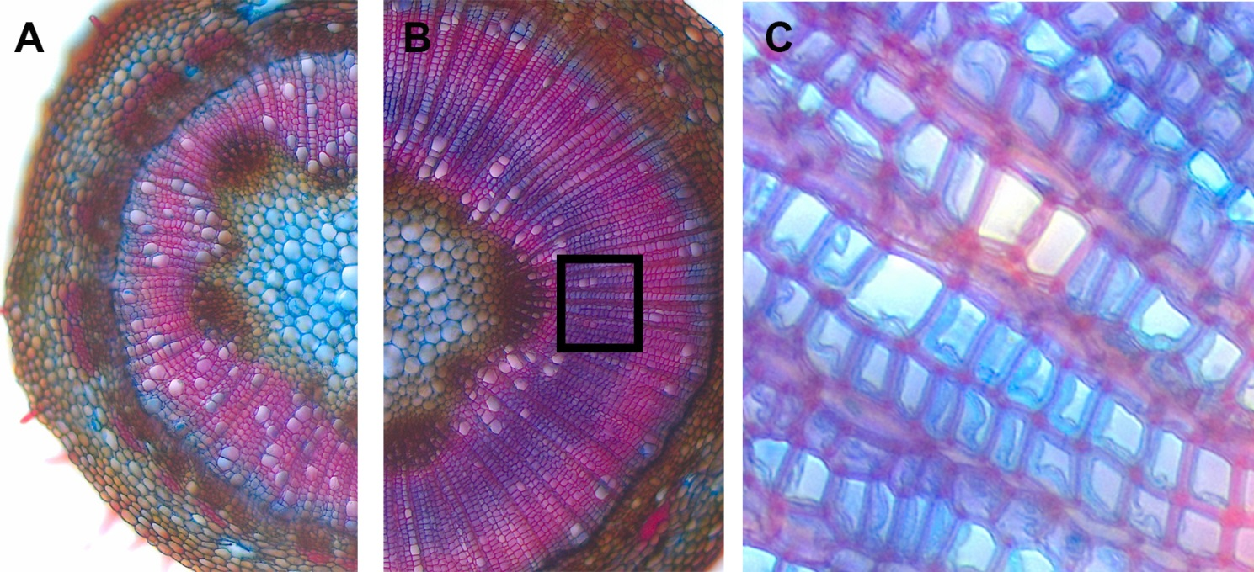
Figure 1. Effect of exogenous stimulation of ethylene signalling on wood anatomy. Safranine-alciane blue -stained hand-section of stems from (A) a water-treated hybrid aspen, (B) an ACC-treated hybrid aspen. Note enhanced xylem width, decreased vessel number, and appearance of a blue-stained area in ACC-treated plants. (C) Magnification of the area marked in B - in blue areas the G-layer in fiber cells is visible.

