WoodApps - Improvement in collaboration along the wood value chain through knowledge-based methods and mobile applications

Project coordinator:
Mr Robert Barkowski
HCN e. V. - Research Association High Competence Network
Poeler Str. 85a, DE- 23970 Wismar, Germany.
Telephone: +49-3841-460016, E-mail: r.barkowski@hcn-group.de

Project partners:
Scheller Systemtechnik GmbH (DE), Slovenian Forestry Institute/ Department for forest techniques and economics (SI), SLU - Swedish University of Agricultural Sciences, Department of Forest Products (SE), Linnæus University (SE), Telecommunications Software & Systems Group, Waterford Institute of Technology (IE)

The technical objective of the project WoodApps was to develop a pilot "Information and Communication Service Platform" (ICSP) to link process partners within international value chains from the forest to the customer - Wood Value Chain (WVC). Using ICT-supported standardized descriptions of business profiles, services, raw-materials and products as well as computer-aided methods and algorithms, the platform is expected to foster an efficient partner communication and the exchange of contrastable information. To optimize the supply of relevant data gained outside, cutting-edge services, realized as smart phone applications as MTT (Mobile Tracking Tool) and MWF (Mobile Workflow Application), have been connected to the platform.

The project partners found out large regional differences in business processes between forest enterprises and the processing industry during the evaluation of the already existing results and findings. In the timber industry it was mainly discovered pronounced regional value chains: up to the entire value chain, from producers and processors/ traders up to the consumers within one region. The business relationships between the actors based to a greater extend on traditional and conservative rules which were agreed upon in decades of practice. These processes are differentially imprinted by a variety of local policies, standards, certification and regulatory standards.

What is still very well recognizable among all process participants, is the interest about a platform that would support them by improving efficiency and quality of their services, commodities or products and would provide an easy and dynamic way to communicate and exchange of data.

Based on these findings and with the aim to get an actively used, industry-capable and practical solution, the project objectives were revised and clarified in relation to the platform functionalities in order to lead the project and its results into a successful future. After the official project end the WoodApps consortium developed a solution that has all the chances to get recognized and supported by the practice.

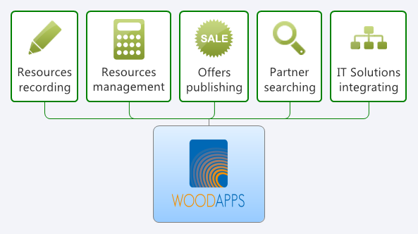
Figure 1: WoodApps task scheme

