**WOBAMA - Wood based materials and fuels**

Project coordinator:

Professor Monica Ek

KTH Royal Institute of Technology

Teknikringen 56, SE-10044 Stockholm, Sweden.

Telephone: +46-8-7906000, E-mail: monicaek@kth.se

Project partners:

Grenoble INP - PAGORA (FR), Aalto University/ School of Chemistry and Technology (FI), IBWCh - Institute of Biopolymers and Chemical Fibres (PL), OrganoClick AB (SE), Casco-Akzo Nobel (SE), Processum Biorefinery Initiative AB (SE), Oy Metsä-Botnia Ab (FI), Stora Enso Oyj (FI), Andritz Oy (FI)

There is a growing demand for the manufacture of highly purified cellulose pulps from wood owing to a declining availability of cotton linters pulp on the one hand (environmental and agricultural restrictions) and an increased production of high value-added cellulose-based products on the other hand. The exploration of new sources and more efficient pulping processes, including bio-refinery, offers good opportunities to improve the ecological balance (CO2-footprint, water and chemicals consumption, use of by-products /reduction of waste) and helps to fulfil the requirements of the future market for renewable raw material based polymers like cellulose acetate. Cellulose acetate as a plant based material is used in very different fields of application, like fibers (textiles, filter materials), films (packaging materials, LCD screens, membranes for water purification), thermoplastics (tools, glasses, pencils) and coatings (pharmaceuticals, paintings).

The WOBAMA project was a research project within the biorefinery concept where forest raw material is converted into value-added products, in similarity to what happens in a conventional oil-based refinery. In the biorefinery concept developed within WOBAMA the focus was on materials, although also fuel could be incorporated in the concept (see Figure 1). The project resulted in demonstrators produced through the new innovative processes developed within the work packages.

The demonstrator include dissolving pulps with high cellulose content, regenerated cellulose films with high tenacity, hydrophobic coatings for cellulose products based on birch bark and adhesives based on polysaccharides from wood. The successful demonstrators show the potential for the WOBAMA biorefinery concept.

A strong focus was to educate young scientists, resulting in five PhD examinations, post doc visits and master thesis projects. A summer school was performed at Pagora, Grenoble 2013, including seminars by professors and industrial representatives on topics from fundamental chemistry within biorefinery concept to applied research in industrial companies to entrepreneurship and innovations, as well as a study tour to Solvay.



Figure 1. WOBAMA work program

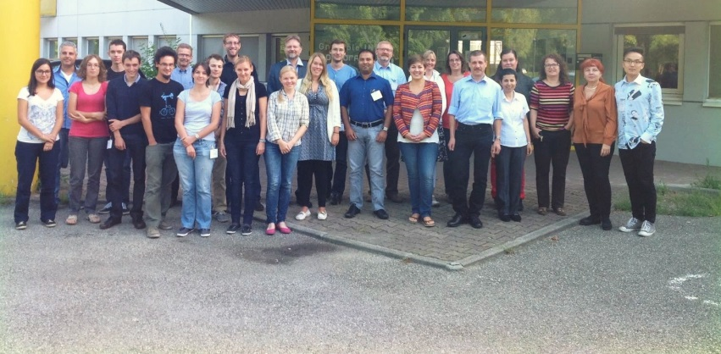

Figure 2. WOBAMA Summer School, Pagora, Grenoble, 2013.