RegioPower - A regional IT-based platform for bringing resource needs and land-based resource production together

Project coordinator:
PD Dr Christine Fürst
University of Bonn, Department of Ecology and Natural Resources Management, Center for Development Research (ZEF)
Walter-Flex-Str. 3, DE-53113 Bonn, Germany.
Telephone: +49-228-734922, E-mail: cfuerst@uni-bonn.de

Project partners:
HCN - High Competence Network e.V. (DE), SLU - the Swedish University of Agricultural Sciences/ Department of Forest Resource Management (SE), University of Helsinki (FI), Simosol Oy (FI), Slovenian Forest Institute (SI)

The challenge for the project RegioPower was to bridge gaps between (i) demand and supply of lingo-cellulosic biomass; (ii) local forest management and regional planning; (iii) forest ecosystem functioning, and integrated regional ecosystem services assessment. The goal was to build a common internet-based platform which interlinks the tools and approaches with the help of case studies conducted within the project.

After intensive work on various theoretical and practical questions the project was able to develop a virtual connection of various land use and land management simulation and assessment tools. Currently available tools are diverse regarding spatial and temporal scales. Additionally, they address different disciplines in science and practice. Nevertheless- or precisely because of this - the tools can be used in combination, thus a number of different stakeholders is addressed.
The tools, which were implemented into the prototype of the platform, are as follows:

• the mobile application Tienoo,
• LandSim, a forest landscape simulation tool,
• the RegioPower feed stock market, and
• the Biomass Module in the context of interactive ecosystem services assessment software GISCAME.

The RegioPower platform is expected to be available online in July 2015. The consortium expects to provide a basis for a growing platform, which involves an increasing number of tools and approaches. This collection currently shows a clear focus on forestry and management of lingo-cellulosic biomass. In the future, this collection should be extended to further biomass used for energy production (incl. energy crops, agricultural residues, and by-products).

The RegioPower platform addresses a wide range of persons and institutions, from private land owners/land managers to regional planners. Persons who want to analyse effects of land management on the provision on ecosystem services or those who are simply interested in sustainable land management and its implications, can visit the platform, inform themselves or request tools for own investigations. Furthermore, the website should act as communication platform for inter- and trans-disciplinary exchange.

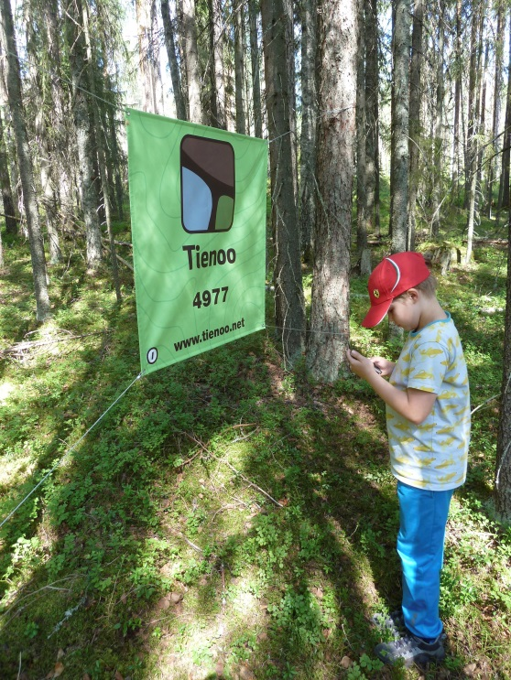
Figure 1: Application of Tienoo in Ruunaa national hiking area, Eastern Finland.

