AGROCOP - Maximizing timber and energy wood production by innovative agroforestry systems with short rotation coppice as intercrop

Project coordinator:
Dr Michael Nahm/ Dr Udo Hans Sauter
Forest Research Institute Baden-Württemberg,
Wonnhaldestrasse 4, DE-79100 Freiburg, Germany.
Telephone: +49-761-4018 237, E-mail: udo.sauter@forst.bwl.de

Project partners:
Albert-Ludwigs University of Freiburg/ Chair of Forest Growth, (DE)
INRA - Institute National de la Recherche Agronomique (FR)
Consiglio Nazionale della Ricerca - Istituto di Biologia Agroambientale e Forestale (IT)
Teagasc - Agriculture and Food Development Authority (IE)

The project AgroCop researched how the production of high quality timber and feedstock wood for energy use can be increased in Europe. Both products will play an important role in the European bio-based economy of the future, but currently, the availability of these resources is rare. AgroCop utilised two innovative management strategies that entail growing wood on agricultural land.

AgroCop examined how these two systems (1. Agroforestry Systems (AFS) for the production of valuable timber wood, 2. Short Rotation Coppice (SRC) for the production of energy wood) can be combined by assessing the use of SRC as an intercrop between rows of high value timber trees, a management approach here called Alley Coppice.

The AgroCop models show that under optimal growth conditions, alley coppice is indeed more profitable than pure SRC. However, under suboptimal conditions, pure SRC is more cost-effective. Moreover, due to the shading of the timber trees, delayed planting can result in further decreased SRC yields – at least when SRC is growing under and between older timber trees with larger crowns.

To make sure that valuable timber trees are trained properly, and to publicise the concept of growing trees among agricultural practitioners, AgroCop produced management guidelines in the language of the different project partners that explain the necessary working steps. Moreover, in collaboration with other projects, AgroCop publicised data on the harvest of the second rotation of SRC, improved algorithms for the representation of tree shape data obtained via Terrestrial Laser Scanning, and quantified the nutrient removal from the field in relation to the tree diameter of SRC trees.

AgroCop has demonstrated how to successfully manage alley coppice systems, and that wood production can be enhanced in rural areas under favourable growth conditions. It is important to carefully choose the site for a future alley coppice system as well as an appropriate management approach. More field data are, however, required to model the biophysical and economic behaviour at a given location with greater precision.

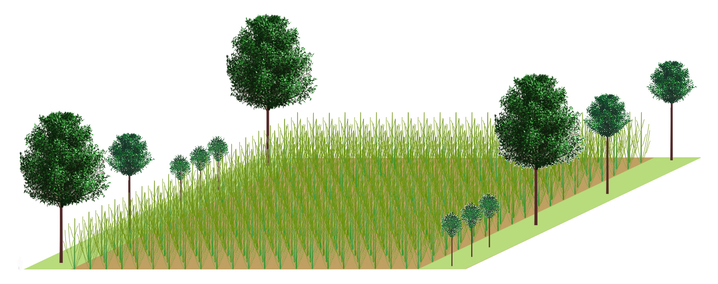(c) C. Morhart

